SonarQube with Jenkins
Create ubuntu machine
sudo su

wget https://raw.githubusercontent.com/akshu20791/Deployment-script/refs/heads/main/jenkins.sh
chmod 700 jenkins.sh
./jenkins.sh

Use this doc to install sonarqube in ubuntu machine
https://medium.com/@deshdeepakdhobi/how-to-install-and-configure-sonarqube-on-aws-ec2-ubuntu-22-04-c89a3f1c2447

- Open the browser and navigate to http://public:9000
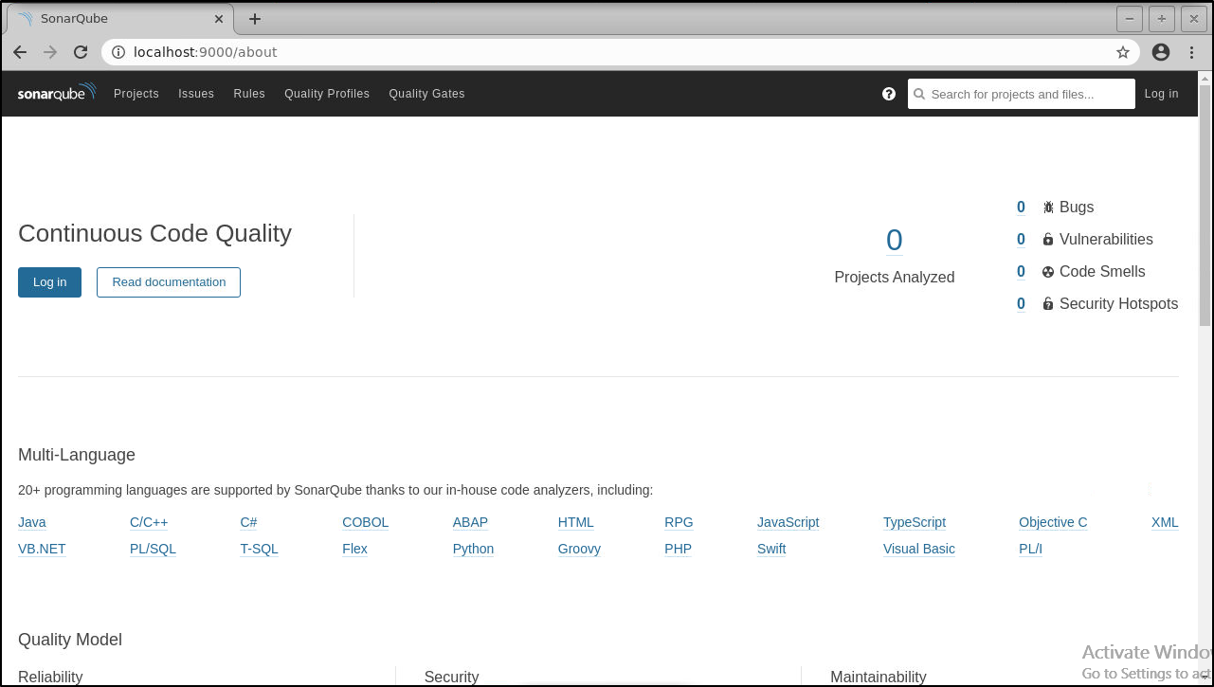
- Log in to sonarqube server with System Administrator credentials (admin/admin)
- Go to Administration > Security > Users > Tokens

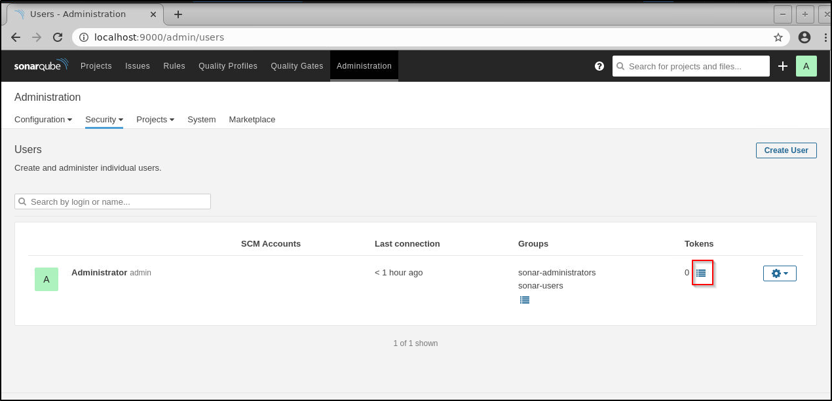
- Click on token and generate a token with name: Jenkins as shown below:
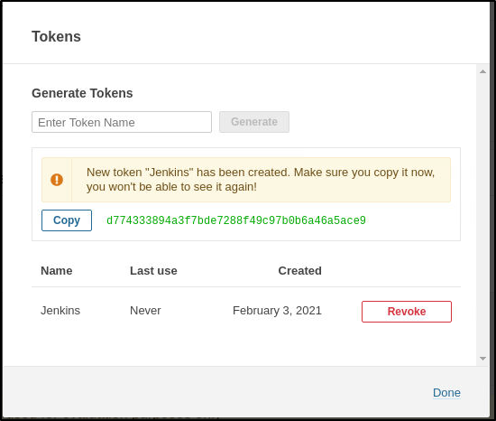
- Copy the generated token and note it down. It will be used in Jenkins for Sonar authentication

Step 2: Installing and configuring SonarQube plugin in Jenkins

- Go to Manage Jenkins > Manage Plugins > Available > search for SonarQube Scanner> Click on install without restart
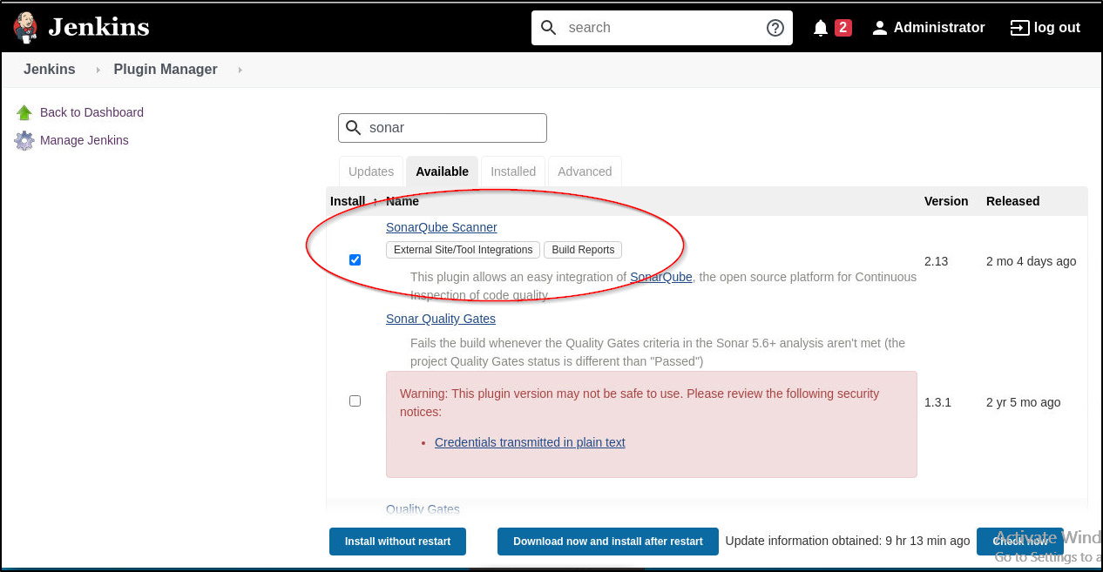
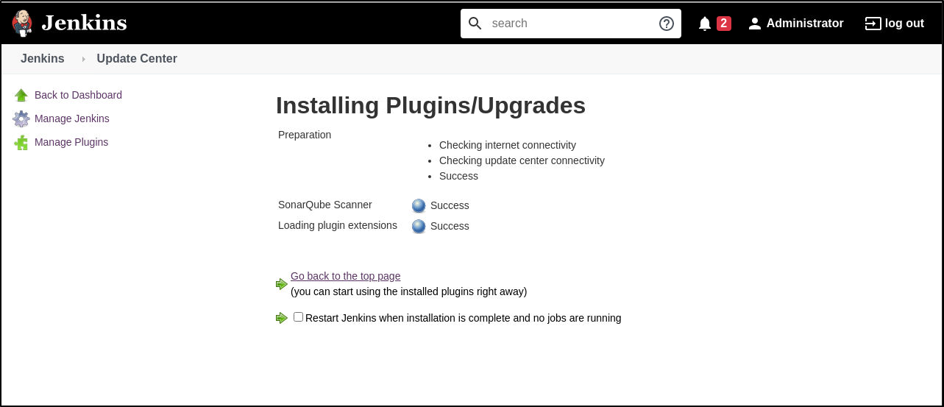

- Go to Jenkins dashboard > Manage Jenkins > Manage Credentials
Click on global
- Click on Jenkins as shown above and in the Global credentials unrestricted page, click on Add Credentials
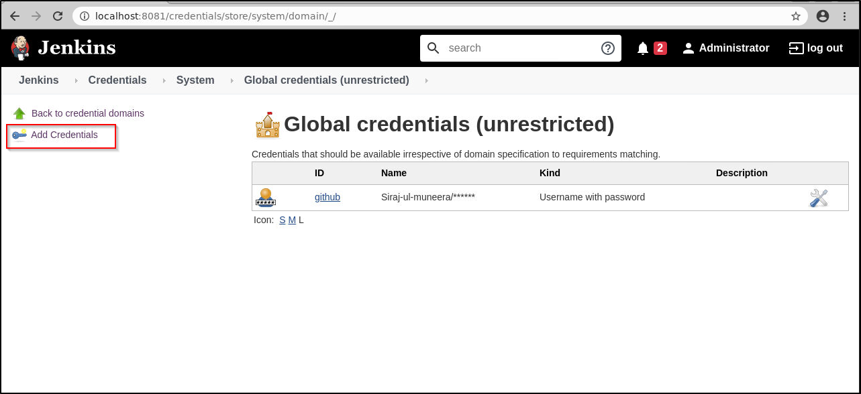
- Select the kind as Secret text from the drop-down. Paste the token that you had earlier copied from the sonarqube server into the Secret field. Give the ID and description as shown below and click on ok.
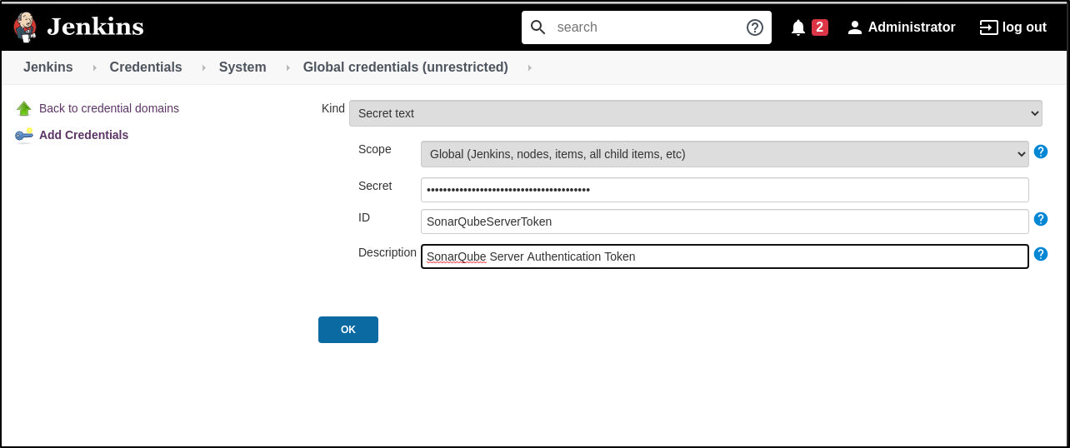
You will see the credentials added in the Global credentials page
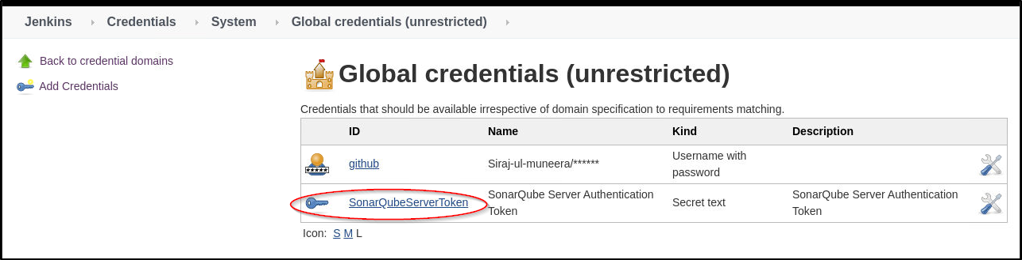
- Go to Jenkins dashboard > Manage Jenkins > system > SonarQube servers section > Click on the checkbox Enable injection of sonarqube server configuration as build environment variable
- Click on Add SonarQube > provide a name (ex: LocalSonarQube) and Server URL as http://localhost:9000. Select the authentication token from the list and click on Apply and Save as shown below:
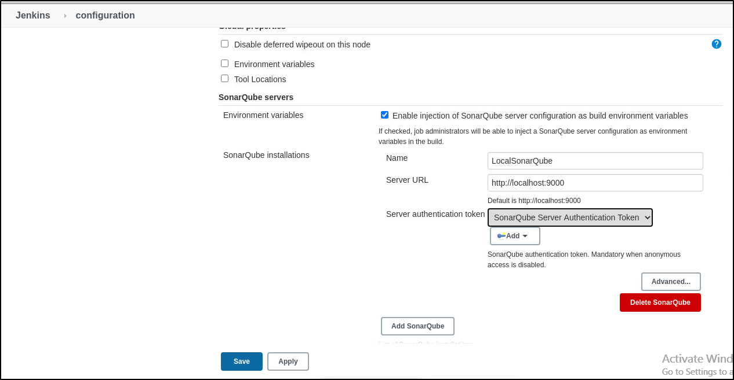
- Go to Manage Jenkins > Global Tool Configuration > Scroll for SonarQube Scanner > Add SonarQube Scanner > provide a name (ex: LocalSonarScanner), check Install automatically and select the version 3.2.0 from the drop-down list as shown below:
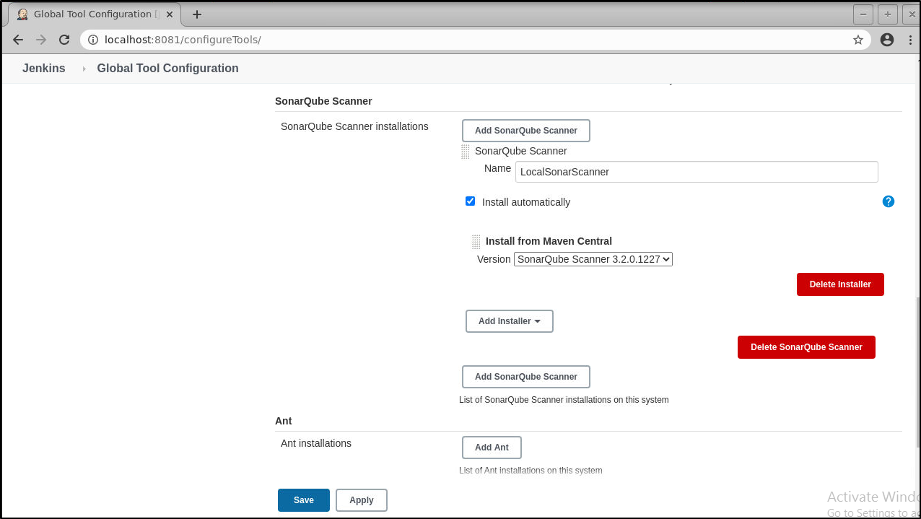
Step 3: Creating a Jenkins job and running Sonarqube Scanner
- Create a new job > provide a name (ex: Sonar-Jenkins), and select project type as freestyle
- Under SCM select Git and enter the git repository of the simple-java-maven-app that we had 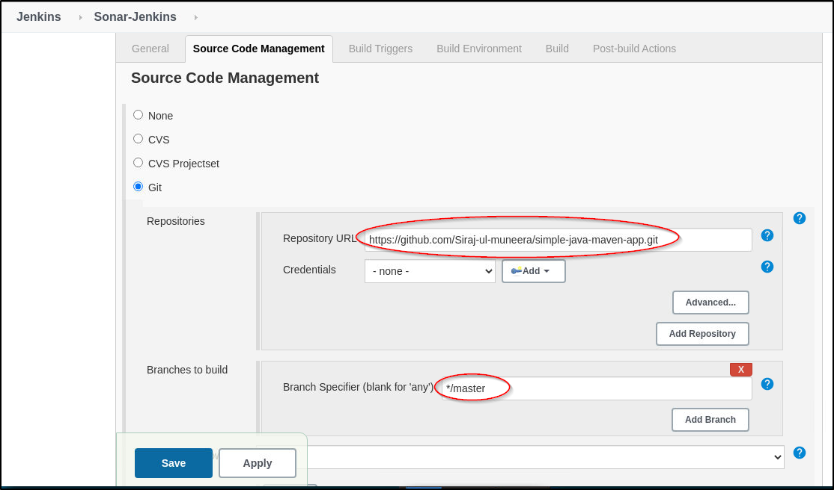created earlier in the
https://github.com/akshu20791/simple-java-maven-app
- In the build section click on Add a build step and select the option Execute SonarQube Scanner from the drop-down list.
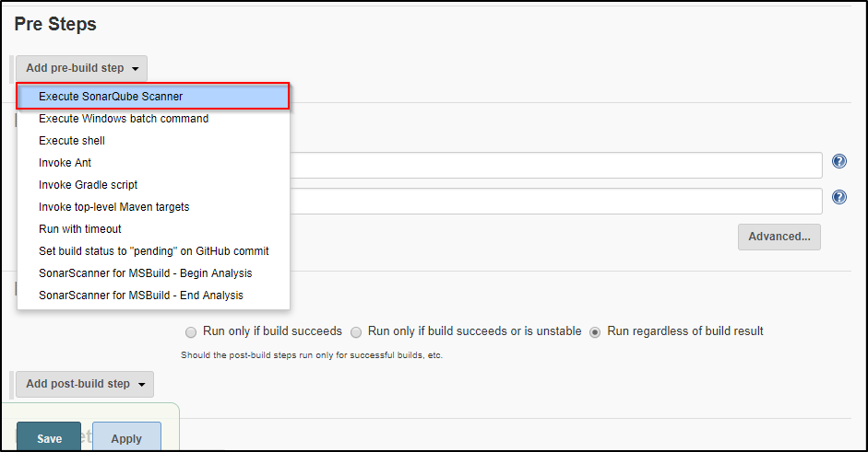

- Enter the details in the Analysis properties section as shown below:
#Required metadata
sonar.projectKey=com.mycompany.app:my-app
sonar.projectName=my-app
sonar.projectVersion=1.0
#Path to Source directory
sonar.sources= ./src
sonar.java.binaries=.

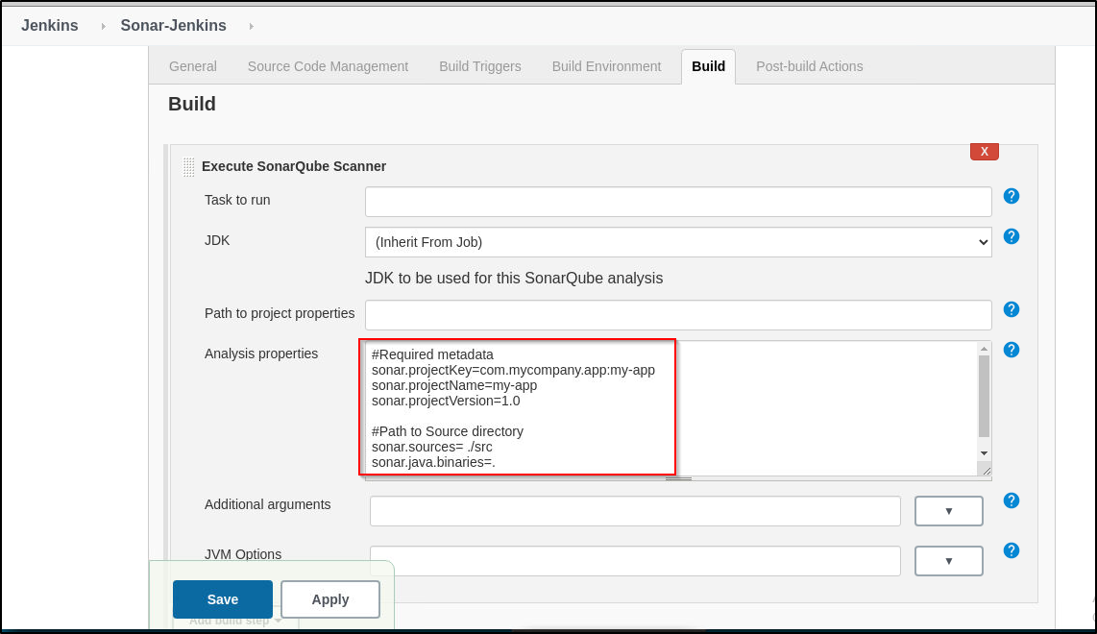
- Click on Apply and Save
- Build the job
- On successful completion of the build from the console output you can see the project in the sonarqube server by clicking the link as shown in the output
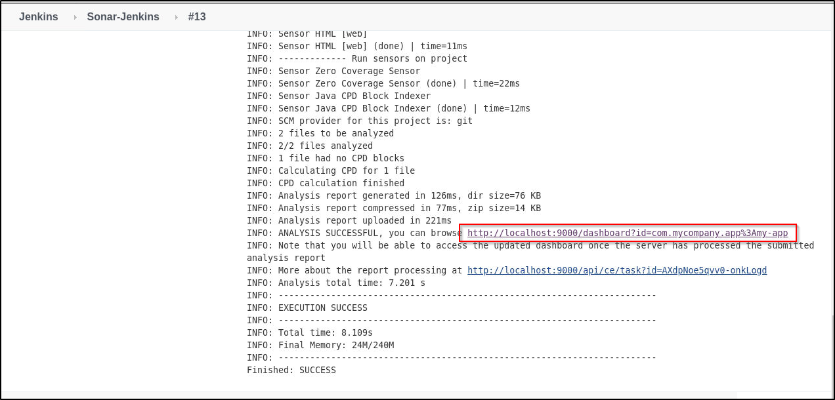

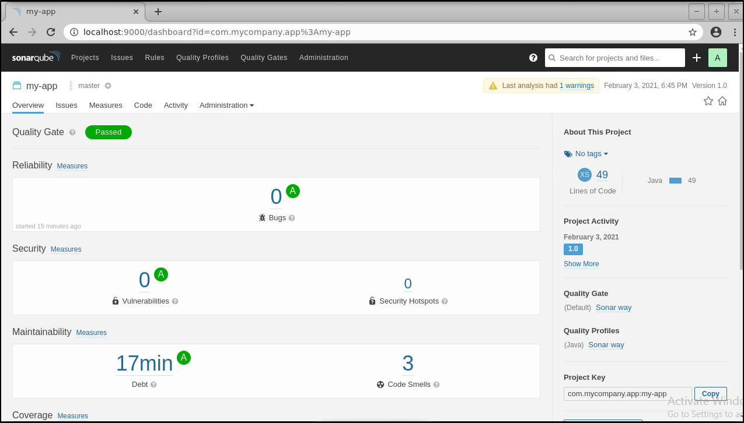You can also check the report on the sonarqube server. From the job dashboard, click on the sonarqube icon, and then click on Projects. You can see the report as shown below:
